asciitube: Scrambled Signal
Category: Web | Difficulty: Hard

Description
Dave escalated. The terminal now accepts only real YouTube links: it pulls the host out of your URL, confirms it's YouTube, resolves the DNS, and rejects anything that lands on a private or loopback address. Every trick from the earlier channels is dead on arrival.
"Try getting to localhost *now*," Dave smirks.
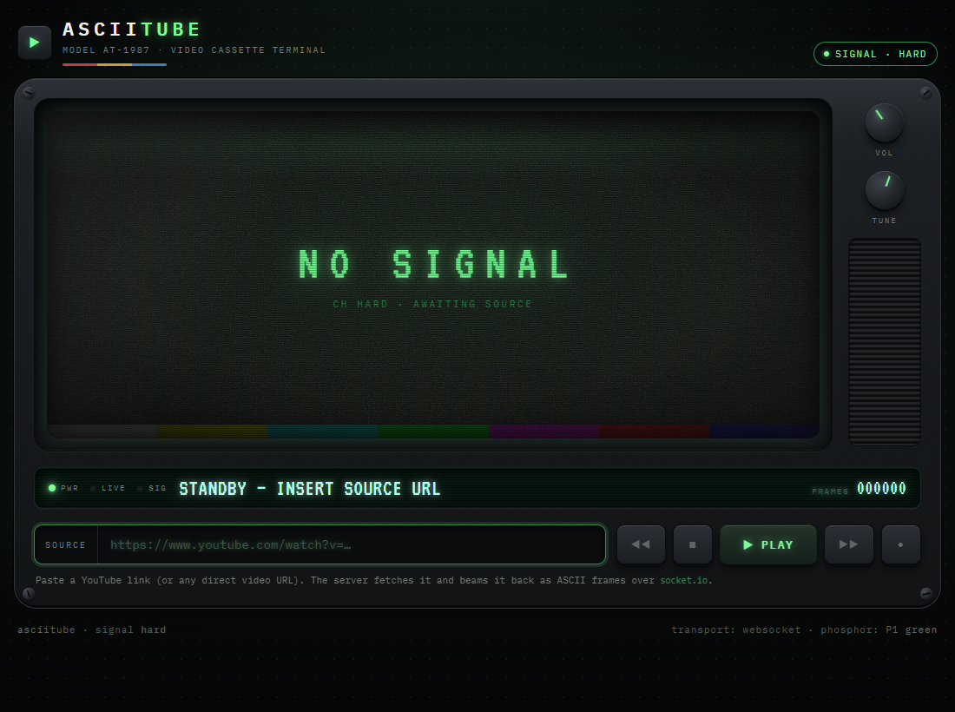
asciitube with the hardened SSRF filters

Files
One hosted Docker container, built from challenge/. From that folder:
cd challenge
docker compose up --build -d # serves http://localhost:5003
Same app family as *Now Playing*, with stacked SSRF filters. The internal flag service (0.0.0.0:9000 inside the container) is never published. The flag is set via FLAG in challenge/docker-compose.yml; the validation lives in challenge/app.py. Reference exploit and writeups are in organizer/: solve/solve_medium.py, solve/exploit.py, README.md, solution.md.

Hint(s)
- Two different parts of the box read your URL — one decides whether it's *allowed*, the other actually goes and *fetches* it. They were written separately, and they don't always agree on where a link points.
- Spend some time with how a URL's "authority" is really structured — the part between the // and the path. A hostname isn't the only thing permitted to live there.

Walkthrough
A parser differential: the validator and the HTTP client disagree about where the URL points. The host is extracted with a hand-rolled regex that grabs the first run of host-ish characters after the scheme and stops at `@`, while requests/urllib3 parse per RFC 3986 (everything before @ is *userinfo*; the real host is after it).
- See the stacked filters. The URL must contain youtube (global gate); literal localhost/127.0.0.1/0.0.0.0/::1/internal are blocklisted; the extracted host must be a youtube domain (allowlist); and that host is resolved and rejected if it maps to a loopback/private/reserved address. Every earlier trick dies — a direct loopback URL is rejected as "not a youtube host":
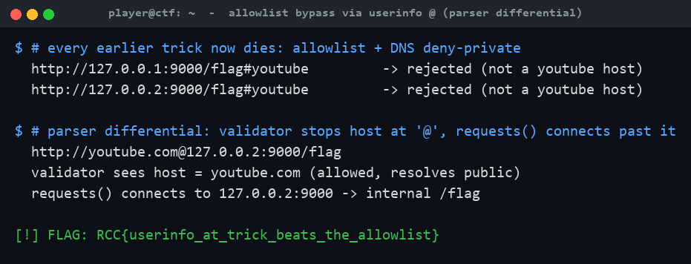
Naive loopback payloads rejected; the userinfo-@ trick leaks the flag
- Split the validator from the client. The host regex (^\s*https?://([A-Za-z0-9.\-]+)) stops at @. For http://youtube.com@127.0.0.2:9000/flag the validator reads the host as youtube.com (actually the userinfo), passes the allowlist, resolves *youtube.com* (public), and passes deny-private — but requests sends the request to 127.0.0.2:9000. Use a non-literal loopback (127.0.0.2, not 127.0.0.1) so the substring blocklist doesn't fire, and keep a youtube domain in the userinfo to satisfy the gate and allowlist:
```
http://youtube.com@127.0.0.2:9000/flag
```
- Read the flag. The client connects to the internal service, which returns text/plain, so the player reflects the body:
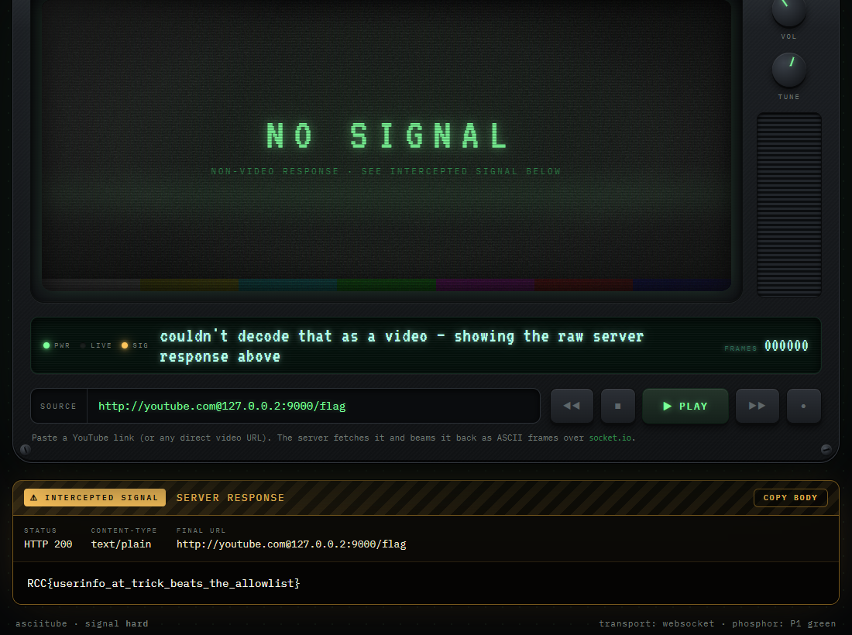
The @ trick: validator sees youtube.com, requests connects to 127.0.0.2:9000
Why deny-private doesn't save it: the check resolves the *validator's* idea of the host (youtube.com), never the address the request actually reaches. Validation and connection must operate on the same parsed host, or an attacker splits them. (Other post-@ encodings like @127.1 or @2130706433 work too.)

Flag
RCC{userinfo_at_trick_beats_the_allowlist}

